KALAWA ARMS SHOP
1. Website Specifications:
The main objective of the gun shop website is to provide an online platform where customers can view available firearms and related products while promoting responsible and legal ownership.
Goals:
To showcase products such as rifles, pistols, accessories in an organized catalogue.
To increase brand awareness and attract new customers.
To provide information about firearm safety, licensing and legal requirements.
To enable customer inquires through a contact form or communication channels.
To build trust by emphasizing compliance with local law and responsible sales practices.
Target Audience:
Adults aged 25-60 years
Individuals interested in firearms for Security, Sport shooting or professional use.
Licensed firearms owners or those selecting legal ownership.
Demographics:
- Gender: Primarily male (but inclusive of all genders)
- Location: Mainly within Botswana (or local region)
- Occupation: Security personnel, law enforcement, hunters, sport shooters, private citizens
Technical Aptitude:
- Basic to intermediate internet users
- Familiar with browsing websites, viewing products, and filling out forms
- Use of smartphones and computers to access the website
- Prefer simple, clear navigation and fast-loading pages

c. Type of Website / Content
Type:
- Product Catalog Website – Displays available firearms and accessories
- Informational Website – Provides legal, safety, and company information
Content:
- Product listings with images and descriptions
- About the business (mission, licensing, compliance)
- Contact page for customer inquiries
- Safety guidelines and legal requirements for firearm ownership

2. Information Design & Taxonomy
a. Information Design:
The website content is organized into clear categories to make navigation simple and user-friendly. The structure ensures users can easily find information about products, the business, and how to make inquiries.
Main Categories:
- Home
  - Introduction to the business
  - Featured products
- Products
  - Rifles
  - Pistols
  - Shotguns
  - Accessories
- About Us
  - Company background
  - Mission and values
  - Legal compliance
- Contact
  - Contact form
  - Phone and location details
Storyboard Flowchart

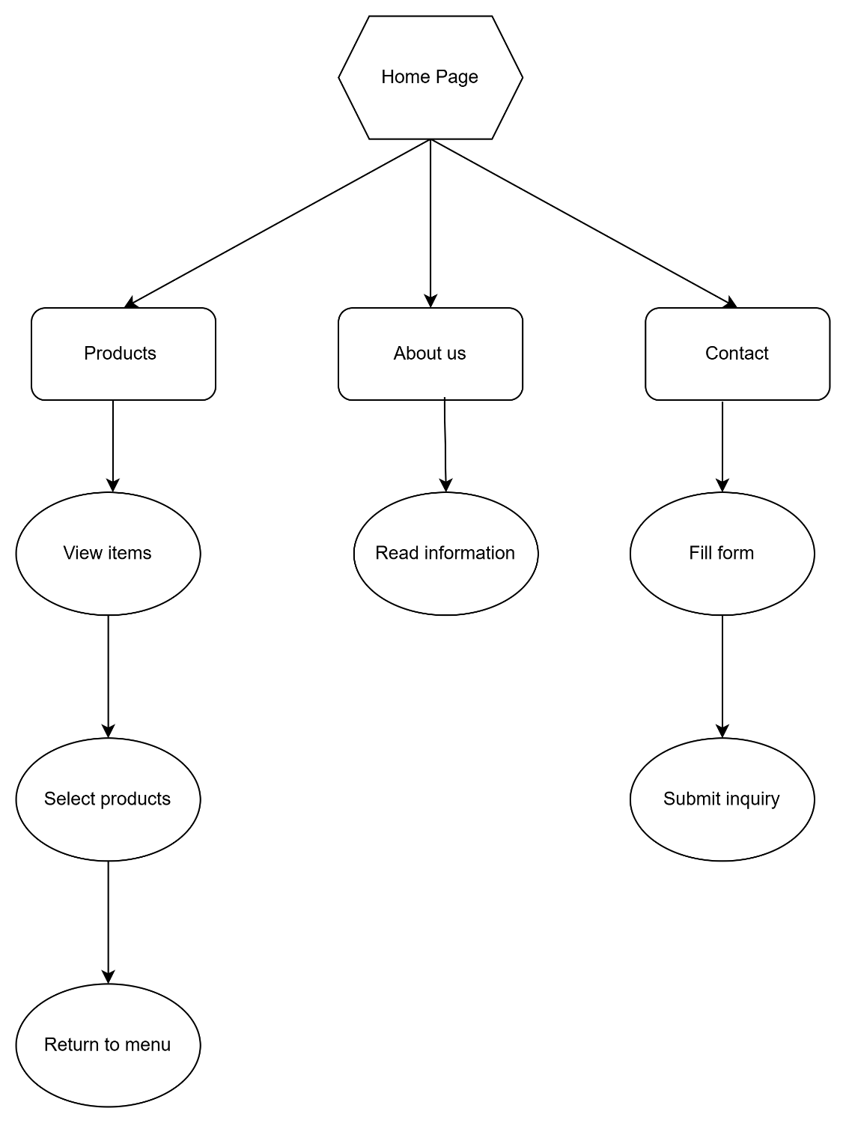

3. Technical Brief

Technologies
HTML5- for structuring pages
CSS3- for styling
JAVA Script-for adding interactivity

Software Tools
Draw io- for diagramming
Visual Studio – code editor

Resources
GitHub- for saving versions of code

4. Page Template Design:
Home page

| KALAWA ARMS SHOP |

| Home | About | Products | Contact |
HERO SECTION
[BIG TITLE]
Welcome to Kalawa Arms Shop
[Short description / tagline]
"Professional security equipment showcase"
[ BUTTON: View Products ]

ABOUT PREVIEW
Short paragraph preview of About page
"Kalawa Arms Shop is a personal project..."
[ Button: Read More ]

PRODUCTS PREVIEW
[Product Card] [Product Card] [Product Card]
Item name Item name Item name
Short text Short text Short text
[ Button: View All Products ]

WHY CHOOSE US
✔ Simple Design
✔ Educational Purpose
✔ Organized Layout
✔ Easy Navigation

CONTACT PREVIEW
Email: example@kalawa.com
Phone: +267 XXX XXX XXX
Location: Gaborone, Botswana
[ Button: Contact Us ]

FOOTER
© 2026 Kalawa Arms Shop

The Home page welcomes visitors to Kalawa Arms Shop.
It gives a short introduction to the website.
It shows what the website is about.
It helps users navigate to other pages like About, Products, and Contact.
It includes buttons that guide users to important sections.

About page

| KALAWA ARMS SHOP |

| Home | About | Products | Contact |
ABOUT US
Welcome message / short intro
"Kalawa Arms Shop is a personal project..."

COMPANY BACKGROUND
[Text Box]
- Project explanation
- Purpose of website
- Learning web development

MISSION
[Centered Box]
- Show website structure
- Practice design skills
- Create realistic layout

VALUES
[Box 1] Professionalism [Box 2] Responsibility
[Box 3] Safety Awareness [Box 4] Integrity
[Box 5] Learning & Growth

LEGAL / PROJECT NOTICE
This is a personal project for learning only.
No real business or transactions occur.

FOOTER
© 2026 Kalawa Arms Shop

The About page explains what Kalawa Arms Shop is.
It describes that this is a personal student project.
It shows the mission of the website.
It explains the values like professionalism and learning.
It includes a notice that this is not a real business.
Contact page

| KALAWA ARMS SHOP |

| Home | About | Products | Contact |
CONTACT US
We’d love to hear from you
Fill in the form or use our details below

CONTACT FORM
Name: [_________________________]
Email: [_________________________]
Phone: [_________________________]
Message:
[___________________________________________]
[___________________________________________]
[ SEND MESSAGE BUTTON ]

CONTACT DETAILS
📧 Email: kalawa@gmail.com
📞 Phone: +267 4633677
📍 Location: Gaborone, Botswana
🕒 Working Hours: 08:00 - 17:00

QUICK INFO SECTION
✔ Fast response
✔ Student project contact page
✔ Simple communication layout

FOOTER
© 2026 Kalawa Arms Shop

The Contact page allows users to send messages.
It includes a form with name, email, and message fields.
It provides contact details like email and phone number.
It shows the location of the business as Gaborone, Botswana.
It helps users communicate with the website owner.
Products page

| KALAWA ARMS SHOP |

| Home | About | Products | Contact |
OUR PRODUCTS
Browse our available security equipment
(Educational / project display only)

PRODUCT GRID
[ PRODUCT 1 ] [ PRODUCT 2 ]
Name: Rifle A Name: Pistol B
Type: Firearm Type: Firearm
Description: Description:
Display mode l Display model
[View Details] [View Details]
--------------------------------------------------
[ PRODUCT 3 ] [ PRODUCT 4 ]
Name: Shotgun C Name: Security Kit D
Type: Firearm Type: Accessories
Description: Description:
Display model Display model
[View Details] [View Details]

CATEGORY FILTER
[ All ] [ Firearms ] [ Accessories ]

FOOTER
© 2026 Kalawa Arms Shop

The Products page displays four sample items.
Each product has a name, type, and short description.
The products are shown in a grid layout.
Users can view details for each item.
This page is for design and learning purposes only.

